Docs CNN
PDF: artificial-inteligence.pdf
https://es.mathworks.com/solutions/deep-learning/convolutional-neural-network.html
https://es.mathworks.com/help/vision/examples/object-detection-using-deep-learning.html

Diseño CNN
Estructura CNN
1 | imageinput | Image Input | 32x32x3 images with 'zerocenter' normalization
2 | conv_1 | Convolution | 32 5x5x3 convolutions with stride [1 1] padding [2 2 2 2]
3 | maxpool | Max Pooling | 3x3 max pooling with stride [2 2] padding [0 0 0 0]
4 | relu_1 | ReLU | ReLU
5 | conv_2 | Convolution | 32 5x5x32 convolutions with stride [1 1] padding [2 2 2 2]
6 | relu_2 | ReLU | ReLU
7 | avgpool_1 | Average Pooling | 3x3 average pooling with stride [2 2] padding [0 0 0 0]
8 | conv_3 | Convolution | 64 5x5x32 convolutions with stride [1 1] padding [2 2 2 2]
9 | relu_3 | ReLU | ReLU
10 | avgpool_2 | Average Pooling | 3x3 average pooling with stride [2 2] padding [0 0 0 0]
11 | fc_1 | Fully Connected | 32 fully connected layer
12 | relu_4 | ReLU | ReLU
13 | fc_2 | Fully Connected | 2 fully connected layer
14 | softmax | Softmax | softmax
15 | classoutput | Classification Output | crossentropyex with classes '0' and '1'
Experimentos

500 muestras:
Distriución de los datos
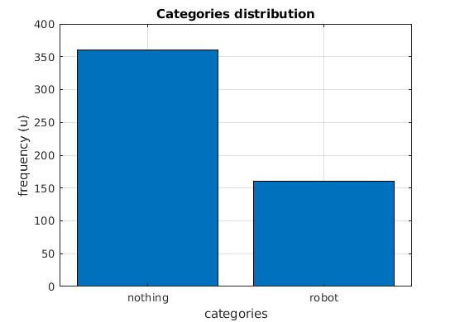

522 muestras:
Resultados del entrenamiento:

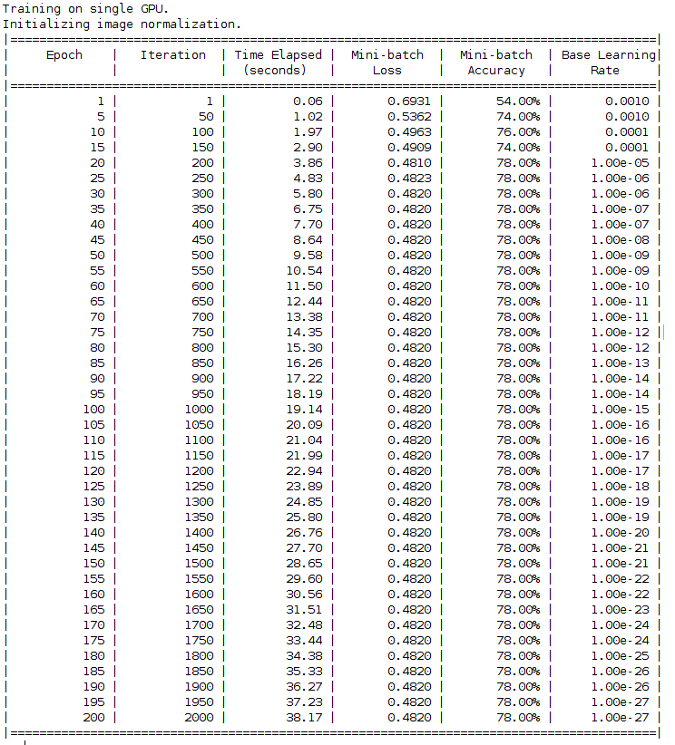

2015 muestras:
Resultados del entrenamiento:

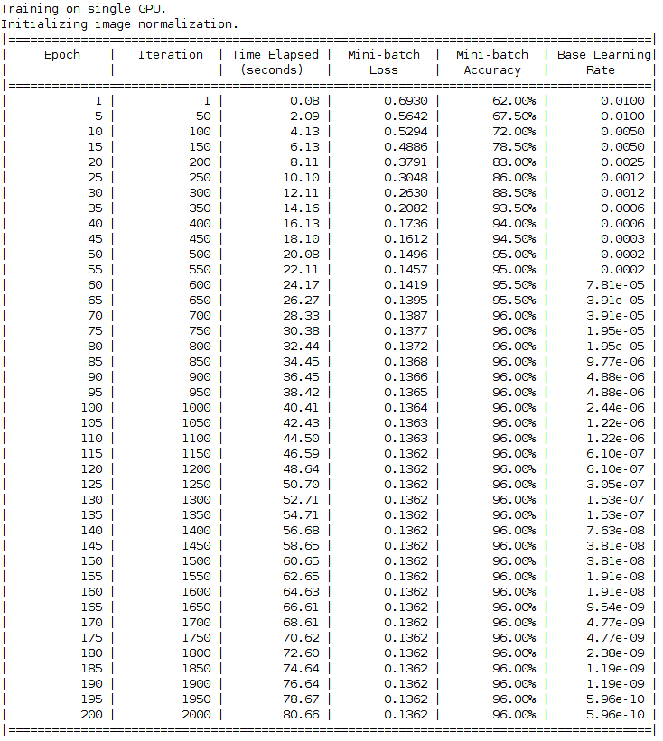

2015 muestras:
Distriución de los datos

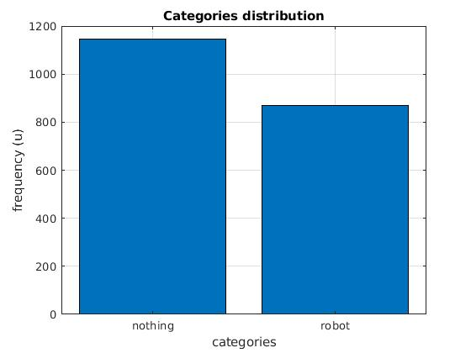
Test con 2015 muestras

Docs SVM
https://es.mathworks.com/help/vision/ref/trainimagecategoryclassifier.html

SVM with 32 matrix images
Number of features | 26522
Number of clusters | 500
Relation features/clusters: 53,04

Coeficient matrix for a 256x256 image SVM classifier
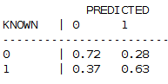

SVM with 256 matrix images

Number of features | 1697382
Number of clusters | 500
Relation features/clusters: 3394,764

Coeficient matrix for a 256x256 image SVM classifier
